# Lab: DOM Manipulation

Problems for exercises and homework for the "Software Technologies Front End" course from the official "Applied Programmer" curriculum.

Use the skeletons from the resources!

You can check your solutions here: <https://judge.softuni.bg/Contests/2787/DOM-Manipulation-Lab>

## Delete from Table

Write a JS program that **takes** an e-mail from an **input field** and **deletes** matching rows from a table. If no entry is found, an **error** should be displayed in a <div> with ID "**results**". The error should read "**Not found**."

### Input/Output

There will be no input/output, your program should instead **modify** the DOM of the given HTML document.

### Examples

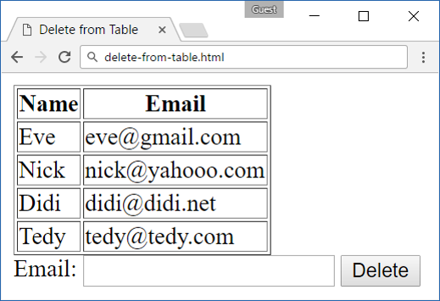 🡪 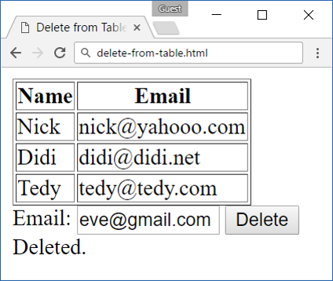

## Stopwatch

Write a JS program that **implements** a web timer that supports **minutes** and **seconds**. The user should be able to control it with **buttons**. Clicking **[Start]** **resets** the timer back to zero. Only one of the buttons should be enabled at a time (you cannot stop the timer, if it’s not running).

### Input/Output

There will be no input/output, your program should instead **modify** the DOM of the given HTML document.

### Examples

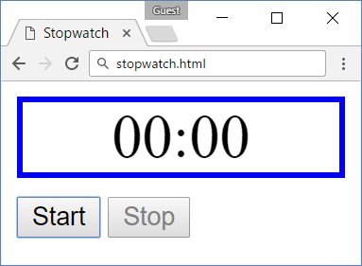

## Mouse Gradient

Write a JS program that **detects** and displays how far along a gradient the user has **moved** their **mouse** on a webpage. Use the provided HTML and stylesheet (CSS) to test locally. The resulting value should be **rounded down** and displayed as a **percentage** inside the **<div>** with ID "**result**".

### Input/Output

There will be no input/output, your program should instead **modify** the DOM of the given HTML document.

### Examples

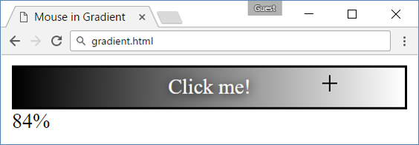

## Highlight Active

Write a JS function to highlight the **currently active** section of a document. There will be **multiple** divs with **inputs** inside them – set the class of the div, that contains the currently focused input field to "**focus**". When focus is lost (**blurred**) **remove the class** from the element.

### Input/Output

There will be no input/output, your program should instead **modify** the DOM of the given HTML document.

### Example

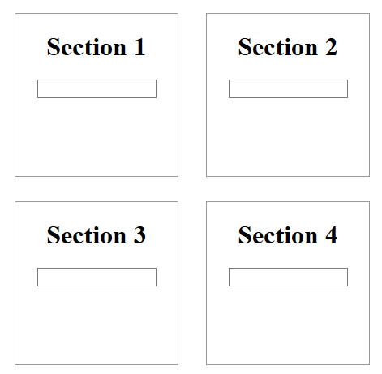 🡪 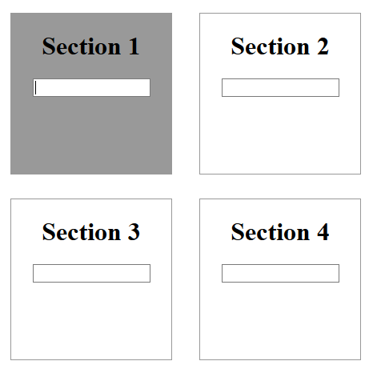

## Dynamic Validation

Write a JS function that dynamically validates an email input field when it is **changed**. If the input is invalid, apply to it the style "error". Do not validate on every keystroke, as it is annoying for the user, consider only **change** events.

A valid email will be in format: **<name>@<domain>.<extension>**

Only lowercase Latin characters are allowed for any of the parts of the email. If the input is valid, clear the style.

### Input/Output

There will be no input/output, your program should instead **modify** the DOM of the given HTML document.

### Example

 